

**Table of Content**

Overview of the Project 2

Scope of the Project 2

Deliverables 2

Scheduling of Resources 3

Budget 3

Risk Mitigation 3

Plan for Communication 4

Strategy for Implementation 4

Keeping an Eye on and Managing 5

Project Termination 5

## Overview of the Project

**Project Title:** Bridging the Digital Divide in the uThukela District with a Basic Bridge

**Sponsor**: Municipality of uThukela District

**Project Manager:** ProTech Team

**Date of Start**: 15 August 2024

**Date of End**: 31 July 2024

**Project Runtime**: One year

## Scope of the Project

Objectives - Create and put into place a world-class, long-lasting network infrastructure for uThukela's major hospital.

• Guarantee dependable and safe Internet access.

• Improve the storage and security of hospital data.

•Teach ICT support employees how to manage the new infrastructure.

## Deliverables

**Infrastructure**

•Network Infrastructure: Fully functional and finished network infrastructure that links the hospital to the Internet.

•Security System: Setup and implemented security controls to safeguard the network.

Training Program: Skilled IT support personnel with the ability to oversee the upgraded infrastructure.

•Documentation: Full project documentation, comprising installation instructions, training materials, and network design.

**Exclusions**

•Maintenance following handover (apart from the specified term of post-implementation support).

• Improvements to the hospital's current equipment beyond network-related parts.

## Gantt Chart

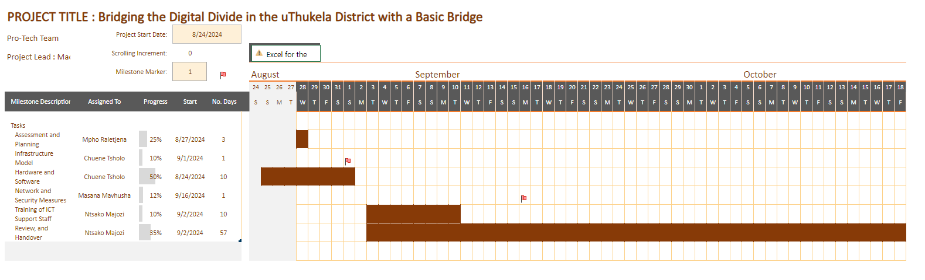

## Scheduling of Resources

**Human Resources**

•Project Manager: Manage the coordination and execution of the project

•Network Engineers: Design and install the network infrastructure

• Put security measures in place

•Trainers: Provide ICT staff with training

•ICT Support Staff: Manage the network after installation

**Materials and Equipmen**t

•Security Software: Tools for data encryption, firewalls, and antivirus software -

•Network Hardware: Routers, switches, servers, and cabling Training Resources: Instructional videos, troubleshooting manuals, and manuals

## Budget

•Costs of Infrastructure: R 2 450 000

•Software and Licensing: R50 000

•Personnel: R1 350 000

•Entire Budget: R 3 850 000

**Handling Risks**

Identification of Risks - Potential security risks; hospital staff resistance to change; delays in the delivery of gear and software

## Risk Mitigation

•Delays: Arrange backup suppliers and stick to reasonable deadlines

•Resistance: Hold change management meetings and include stakeholders as soon as possible

•Security: Carry out frequent security audits and phase-in the implementation of security measures.

## Plan for Communication

Communication with Stakeholders

•Weekly Team Meetings: Talk about the status and resolve concerns;

•Bi-Weekly Stakeholder Updates: Send written updates to the hospital management and the uThukela District Municipality;

• Monthly Reports: Comprehensive summaries on the status of the budget, risks, and milestones;

Mechanisms for Feedback

• Regular Surveys: Get input from hospital employees both before and after implementation

Issue Tracking System: Track and address issues that stakeholders have raised by using a platform such as Jira or Trello.

## Strategy for Implementation

Rollout in Phases

• Install security measures concurrently with network installation

•Begin with network design and hardware configuration

•Conduct pilot testing before full deployment

**Instruction and Assistance**

•Training Sessions: Give ICT employees practical instruction in small, manageable groups.

• Support: Provide assistance during the transition phase and set up a clear channel of communication for any problems that may arise.

## Keeping an Eye on and Managing

Monitoring Performance - Keep an eye on assignments, due dates, and progress using project management software.

•Update the project progress on a regular basis and make any required revisions.

Quality Assurance

•Make sure deliverables fulfill the necessary requirements by implementing quality checks following each process.

Change Management

• Immediately notify stakeholders of any changes to the scope, schedule, or resources by documenting them.

## Project Completion

Complete Evaluation and Testing

•Evaluate project results in relation to goals and success criteria

•Carry out a thorough final test of the network and security systems

Handover

•Transfer ownership formally of the completed network infrastructure to the hospitals ict team

•Provide all necessary documentation and support contacts

Post-implementation support

•Offer a support window (3-6 months) to address any post-implementation issues

•Conduct a final project review meeting with stakeholders to gather feedback and discuss lessons learned.